Paper Title in Title Case
(Each Word of the Title Should be Capitalized)

Author Name [Leave Blank]
Article Title: Garamond, Size-18pt / Line Spacing: Single-18pt / Paragraph Spacing: Above Paragraph-0pt, Below Paragraph-0pt
Because of the double-blind review, the authors’ information should not be included in this file. Please input authors’ information in the relevant fields of the Paper Submission Portal
ABSTRACT
This file provides a template for final papers submission for the UD26 – Belonging conference. The paper in MS-Word format should be written in compliance with these instructions. An abstract not exceeding 350 words should appear on the top of the first page, after the title of the paper.
Key Words: Keyword¹, Keyword², Keyword³, Keyword⁴

Main Text
We only accept text files or files in .doc or .docx format (such as from Microsoft Word or Open Office) and .pdf format. It is expected that authors will submit carefully written and proofread material. Spelling and grammatical errors, as well as language usage problems, are not acceptable in the final submission. The paper length should not exceed 4,000 words (including title, abstract, keywords, main text, footnotes, captions and references) with a minimum of 2,500 words.
Submissions must be fully anonymized to ensure double-blind peer review. Please remove all author names, affiliations, acknowledgements, and self-identifying references from the manuscript. References to the authors’ own work should be written in the third person. Metadata identifying the authors must also be removed from the file properties.
Papers should clearly present the research context, objectives, methodology or design approach, and main arguments or findings. The structure should be coherent, well organized, and written in clear academic English.
Technical terms should be explained. Acronyms should be written out at their first appearance.

paper format
Please note the following details: this template is an A4 format with 20 mm margins left, right, top and bottom. Header and footer shall be positioned 16 mm from the edge.
All text paragraphs should be single spaced, with first line intended by 10 mm. Spaces to be used before and after headings and subheadings are shown in this example. Position and style of headings and subheadings should follow this example. No spaces should be placed between paragraphs. Please DO NOT change any of the above-mentioned page, paragraph, and font settings.

Header, Footer, Page Numbering
If this template is used when writing the paper, headers and footers will be set automatically.

Fonts
If you’re using Microsoft Word, UD26 template coherent styles are available in the Styles Pane.
Papers should use 12-point Garamond (bold, italic and underlined).
It is recommended that text in figures is not smaller than 10-point font size.

Tables and Figures
Figures (maximum 6) must be properly referenced and captioned. Please indicate clearly in the text where each figure should appear (e.g. [Figure 1 here]) and include a caption for each figure.
All figures must be submitted as JPEG files, at a resolution of 1500 pixels on the longest side. Images should be clear and suitable for digital publication.
Authors are solely responsible for securing all necessary reproduction rights for images, diagrams, and other visual material included in the paper. By submitting their work, authors confirm that they hold the rights to use all visual material and that proper credit has been given where required.
Tables should be referred to and included in the text. Each table, figure and illustration should be numbered consecutively (in Arabic numbers) and titled. Headings and captions styles for tables and figures are available in this template. The following is the example for Table 1.
Table 1 Title of Example Table
 | CFI | TLI | RMSEA
Single common factor model | 0.772 | 0.744 | 0.104
Two-factor model | 0.886 | 0.893 | 0.060
Six-factor model | 0.811 | 0.787 | 0.106
Revised five-factor model | 0.954 | 0.943 | 0.042
Table headings should be centered above the tables. Figure captions should be centered below the figures.
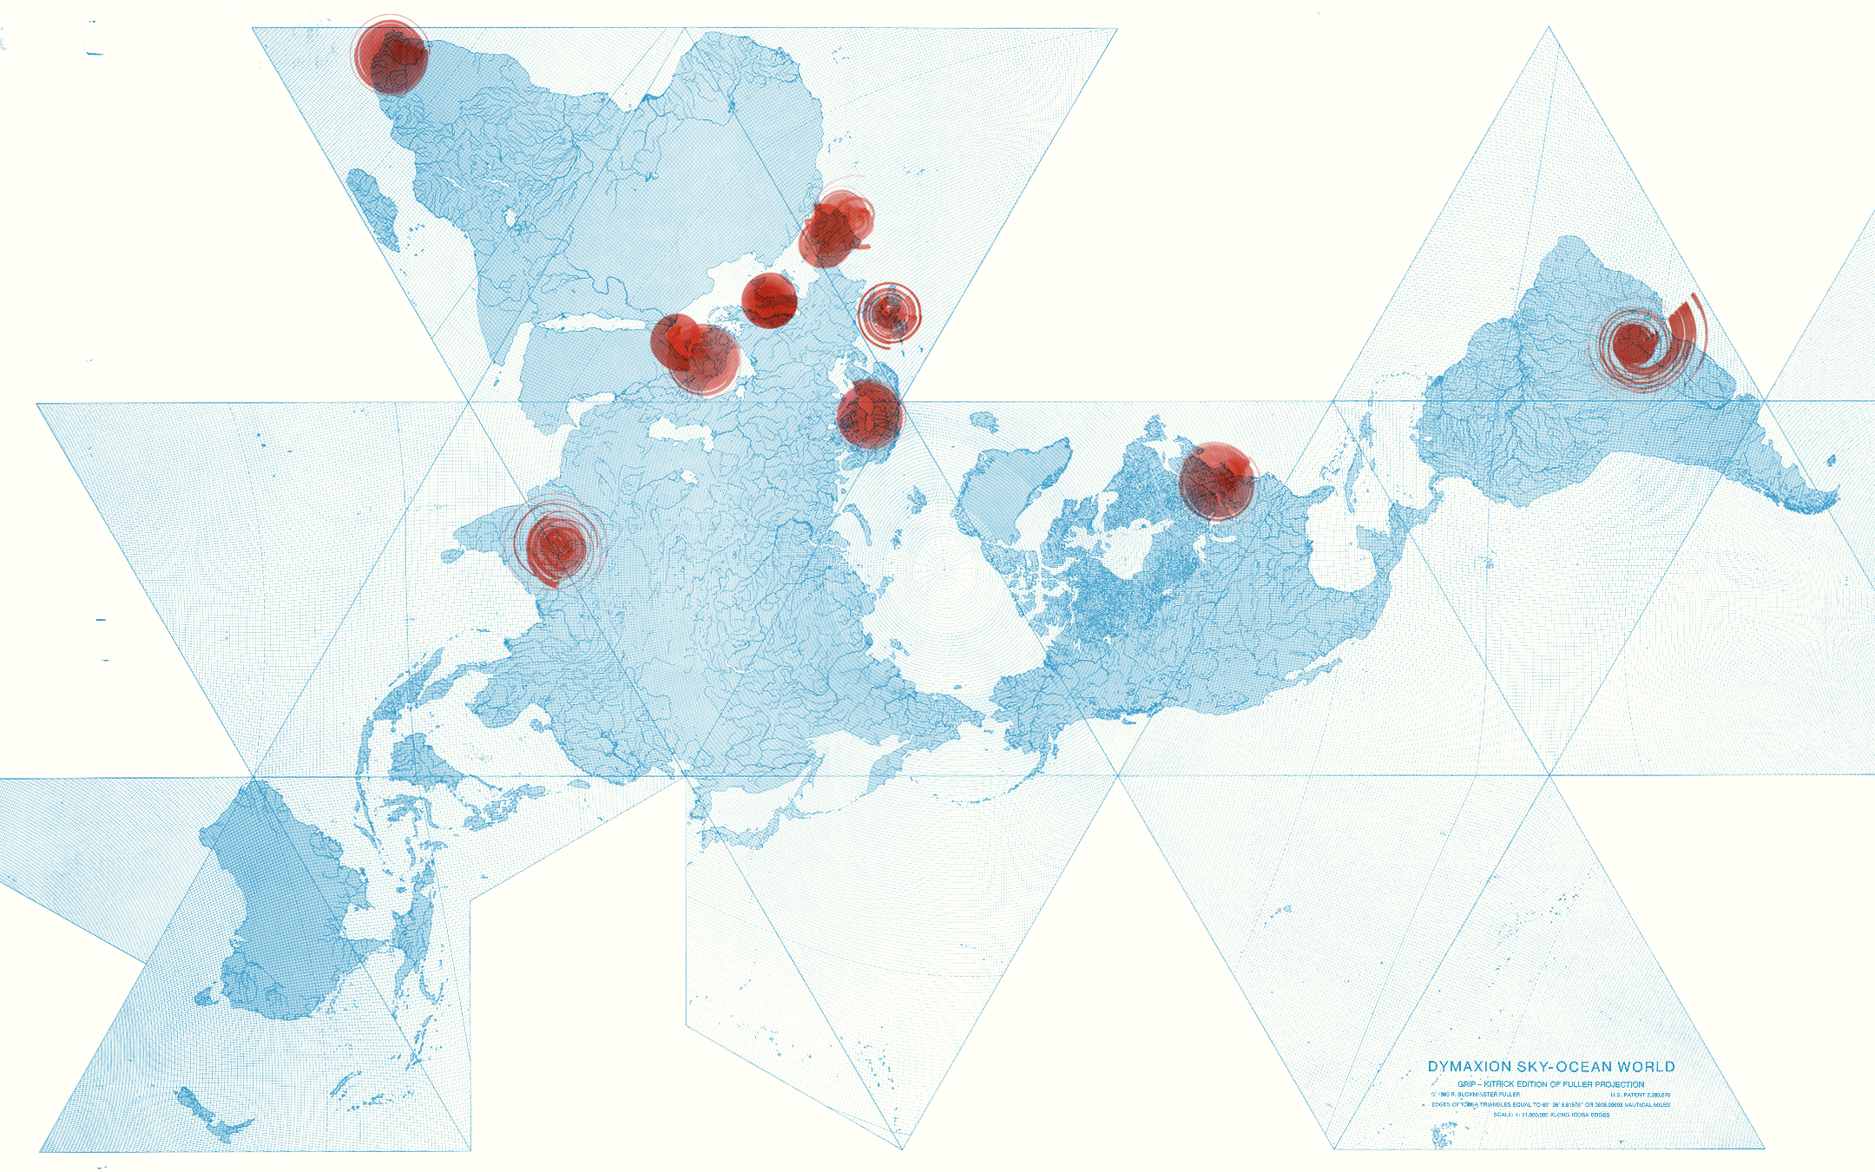
Figure 1: Title of Example Figure
All figures, tables, images, etc. must credit a "source" of the image/graphic. If the image/graphic was created or generated by the author(s), then please list the Surname and a year. If the image/graphic was not created by the author(s), please provide the source from which the figure was obtained.

References
Papers should be supported by references. References must be listed at the end of the paper. Do not begin them on a new page unless this is absolutely necessary. Authors should ensure that every reference in the text appears in the list of references and vice versa. References should be presented in accordance with the APA (7th edition) style. Consistency and accuracy in citations and reference lists are required.
In-text citations should include the author’s surname and the year of publication in parentheses, with page numbers provided when quoting directly (e.g., (Miller, 2000; Tribe, 2000, 2001) or Miller (2000, p. 18) notes that …). Where there are two or more works by the same author published in the same year, lowercase letters should be added after the year (e.g., (Smith, 1999a, 1999b)). For works with two authors, both surnames should be cited every time using an ampersand in parenthetical citations (e.g., (Clarke & Little, 1996)). For works with three or more authors, only the first author’s surname should be cited, followed by et al. from the first citation onward (e.g., (Riley et al., 1996)). The reference list, placed at the end of the manuscript, must be typed in alphabetical order of authors.
The specific format is:
- For papers in journals: Stergiou, D., & Airey, D. (2012). Using the course experience questionnaire for evaluating undergraduate tourism management courses in Greece. Journal of Hospitality, Leisure, Sport & Tourism Education, 11(1), 41–49. https://doi.org/xxxxx (if available)
- For books and monographs: Tribe, J. (2012), The Economics of Recreation, Leisure and Tourism (4th edition), Butterworth-Heinemann.
- For chapters in edited books: Spector, P. (2001), Research methods in industrial and organizational psychology. In N. Anderson, D.S. Ones, H.K. Sinangil, & C. Viswesvaran (Eds.), Handbook of Industrial, Work and Organizational Psychology (pp. 10-26), Sage.
- For reports: European Travel Commission (2012). European Tourism in 2012: Trends and Prospects (Quarterly report Q3/2012). ETC.
Please refrain from using any of the "citations and bibliography" tools or features in Microsoft Word. These are not editor-friendly software tools, and they cause numerous problems during typesetting. Citations and references should be entered as regular text without the aid of any special features or tools.
For detailed guidelines, see:
https://apastyle.apa.org/style-grammar-guidelines

SUBMITTING THE Paper
In order to submit a paper, you need to follow the instructions you received on the abstract acceptance email.
All submissions should omit all author-identifying material for a two-way anonymous peer review. Submissions must not appear on any publicly visible website to avoid compromising the validity of an anonymous review.
Papers have to be submitted before the 15th of April 2026.
ACKNOWLEDGMENT
Indication of institutional or personal acknowledgments to entities that collaborated in the research project.
REFERENCES
American Psychological Association. (1972). Ethical standards of psychologists. American Psychological Association.
Anderson, C. A., Gentile, D. A., & Buckley, K. E. (2007). Violent video game effects on children and adolescents: Theory, research and public policy. Oxford University Press. http://dx.doi.org/10.1093/acprof:oso/9780195309836.001.0001
Beck, C. A. J., & Sales, B. D. (2001). Family mediation: Facts, myths, and future prospects (pp. 100-102). American Psychological Association. http://dx.doi.org/10.1037/10401-000
See https://apastyle.apa.org/style-grammar-guidelines/references/examples

Notes
- Notes should be added as endnotes. This is an example.

